Technical report

1. Formal problem description
The problem addressed in this project was named Mars Observation Scheduling Problem (MOSP) and formally defined as follows:

The Mars Express spacecraft is given a set O of orbits around Mars. The satellite travels more than one orbit per day, but MARSIS radar can collect data for up to T seconds. It is required to plan, for each day, the beginning of every observation activity, with the objective of maximizing profit and coverage of the target area, respecting all operational constraints.

The various aspects of the formulation and data to be used are detailed below:
- The orbits to be covered by the satellite will be obtained through SPICE software. The description of the orbits will contain the geographical coordinates (latitude, longitude and altitude) of the trajectory as well as the date on which it will be travelled.
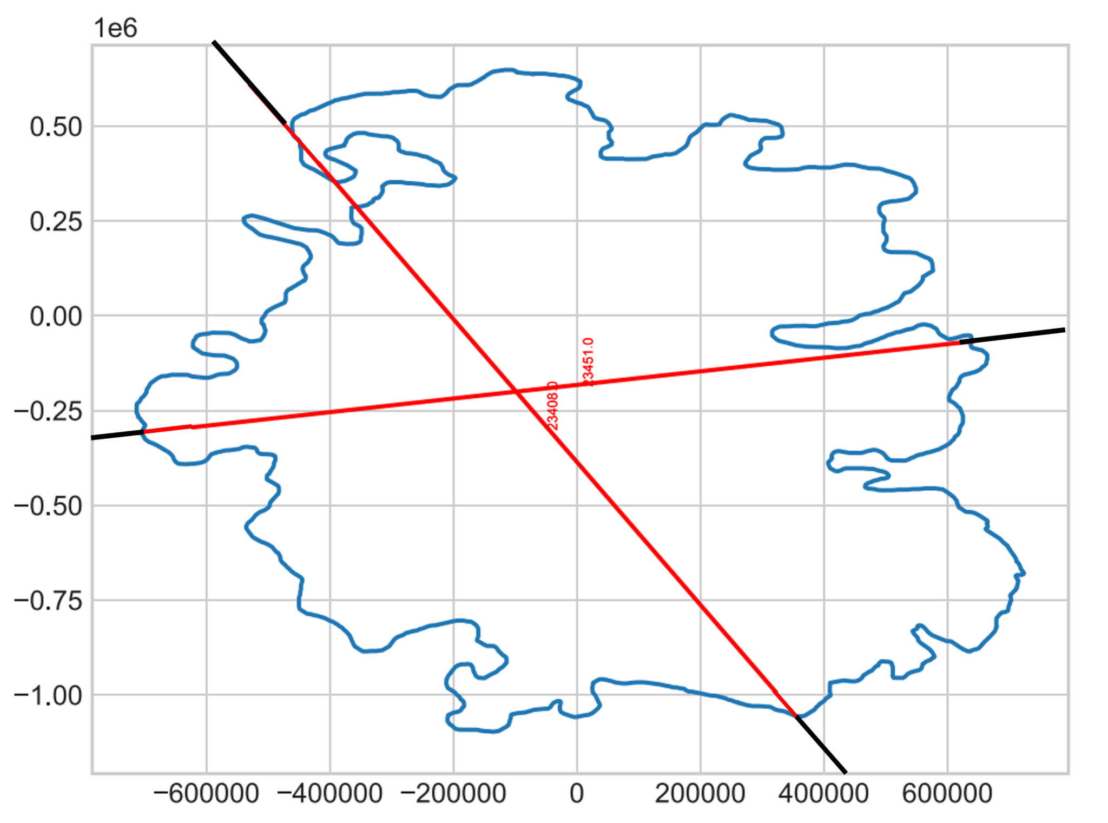
- The target area is the South Pole of Mars. In fact, great attention is paid to the observation of this area, as in 2018 evidence of the presence of liquid water in the subsoil was found. The South Pole will be identified by its boundary coordinates. Therefore, the orbits to be considered will be filtered to consider only the part overlapping the south pole (Figure 1).

Figure 1: Time window for observations in orbits 23408 and 23451

- Additional filtering is imposed by the possibility of making observations only within a time window that goes from 15 minutes before to 15 minutes after the pericenter of the orbit. Therefore, not all orbits are eligible, even if they pass over the South Pole.
- The time limit T for daily observation is set at 134 continuous seconds, in accordance with current operating procedures. Other T values, such as sensitivity analysis, may be studied. The value of daily T is derived from a realistic approximation of the time window between two data download times. We assume that the memory is emptied every day when the satellite reaches the apocenter of orbit, a position from which it is easier to communicate with stations on Earth.
- The profit to be maximized concerns (i) the coverage of the South Pole of Mars also considering the current state (some areas have already been observed) and (ii) the resolution or quality of the observations. The latter can be obtained by machine learning algorithms trained on the historical dataset of observations. In addition, (iii) some areas are more likely to hide water, so they may have a greater preference for being observed (Figure 2).
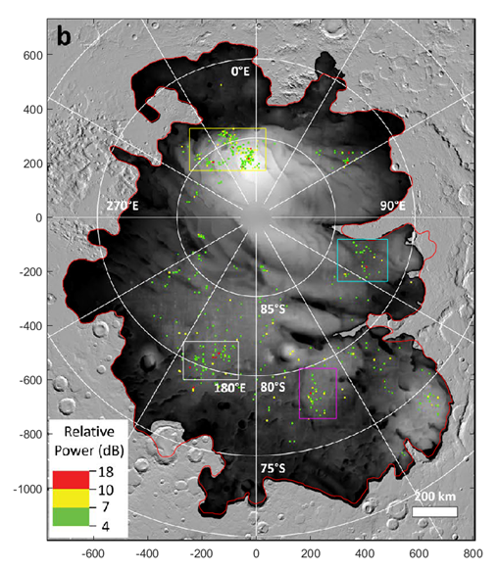

Figure 2: Four preferred zones, delimited by colored boxes

2. Input data processing

To address the problem, it was necessary to produce a schematic representation of the data and make some simplifications. In particular, the surface of Mars was discretized in a grid where each point, called a point of interest (PI), is the representation of a square portion of the total surface and whose step is a parameter of the problem. Instances with discretization steps equal to 1km, 2km, 3km, 5km and 10km will be produced.

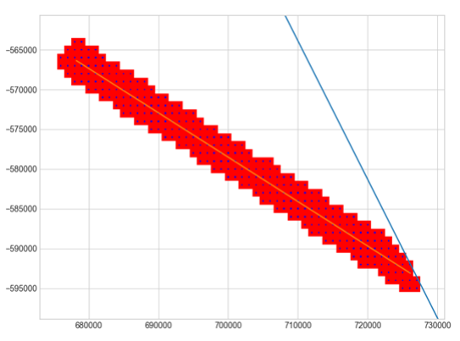
We therefore define “observation” as an orbit segment, corresponding to a time window in which the radar is observing a strip of land, i.e. a set of PIs (Figure 3). Each observation has a duration of T seconds and covers a set of PIs, depending on the trajectory traveled. This intersection is calculated using the coordinates of the orbital trajectory and the coordinates of the PIs. Furthermore, the altitude of the satellite allows to determine the MARSIS viewing range.

Figure 3: An observation (in red) corresponds to the set of PIs (in blue) that are covered by the spacecraft during its trajectory (in yellow)

In the pre-processing phase, the characteristics of all observations are calculated. Furthermore, each PI contained in the observations will be associated with a “quality” value derived from machine learning, based on the time in which it will be observed within the given observation. The qualities of the PIs will contribute to the calculation of the profit to be maximized, but each PI can be considered only once (even if covered by multiple observations). Furthermore, for each PI already observed in the past, only the quality gained will be considered, calculated as the difference between the quality predicted by machine learning and that recorded in the history.

